SciENcv

Instructions for Adding a Delegate

- Login to SciENcv
https://www.ncbi.nlm.nih.gov/sciencv/

You can login with your NSF ID, eRA Commons ID, or in more options using Google with your IIT email address.

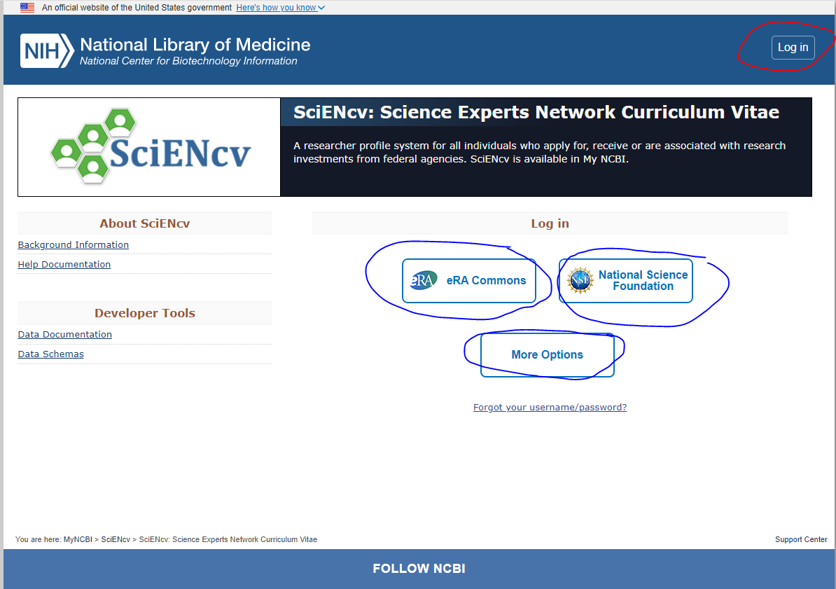

- Click on your account in the upper right corner.

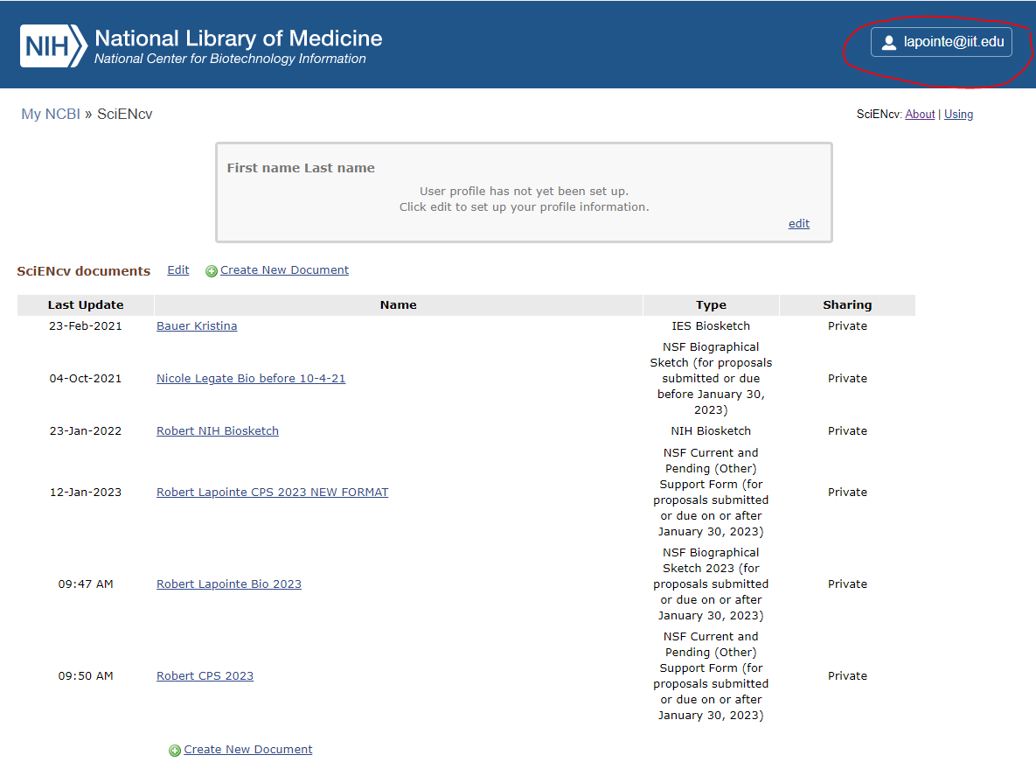
- Click on Account settings

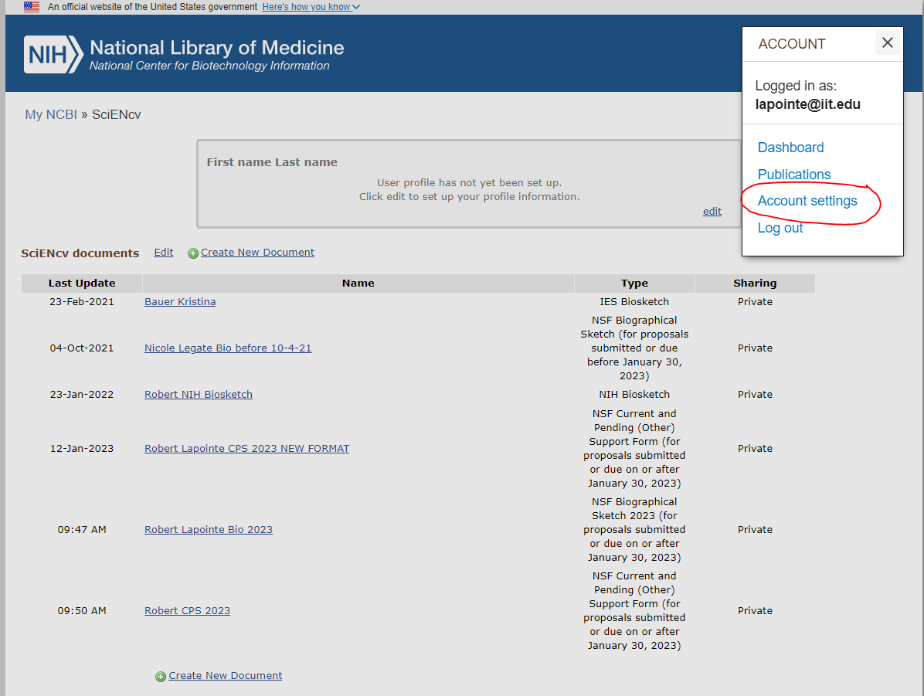

- Click on Add a Delegate and enter osrp@iit.edu into the pop-up box and press the OK button

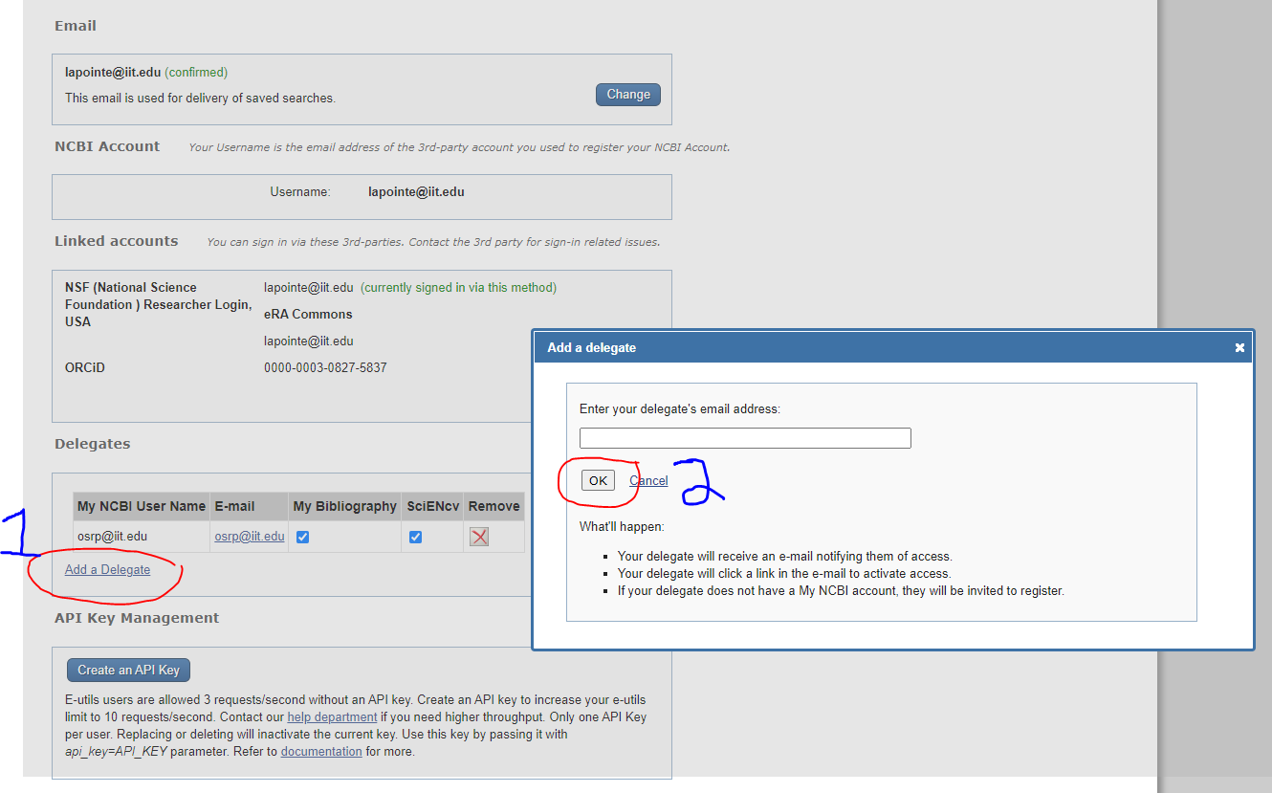

An email will be sent to osrp@iit.edu and the OSRP team will be able to access your SciENcv account to create current and pending support.

